ENZYMES
Introduction:
Enzymes are catalysts that, within the mild conditions of temperature, pH, and pressure of the cells, carry out chemical reactions at amazing high rate. They are characterized by a remarkable efficiency and specificity.
Substrates are the substances on which enzymes act. A substrate binds to the active site of an enzyme and is converted into products. Once the products leave the active site, the enzyme is ready to attach to a new substrate and repeat the process.

Enzymes are both proteins and biological catalysts (biocatalysts). Catalysts accelerate chemical reactions. Almost all metabolic processes in the cell need enzyme catalysis in order to occur at rates fast enough to sustain life. Metabolic pathways depend upon enzymes to catalyze individual steps. The study of enzymes is called enzymology and a new field of pseudoenzyme analysis has recently grown up, recognizing that during evolution, some enzymes have lost the ability to carry out biological catalysis, which is often reflected in their amino acid sequences and unusual 'pseudocatalytic' properties.
Enzymes are known to catalyze more than 5,000 biochemical reaction types. Other biocatalysts are catalytic RNA molecules, called ribozymes. Enzymes' specificity comes from their unique three-dimensional structures.
Like all catalysts, enzymes increase the reaction rate by lowering its activation energy. Some enzymes can make their conversion of substrate to product occur many millions of times faster. An extreme example is orotidine 5'-phosphate decarboxylase, which allows a reaction that would otherwise take millions of years to occur in milliseconds. Chemically, enzymes are like any catalyst and are not consumed in chemical reactions, nor do they alter the equilibrium of a reaction. Enzymes differ from most other catalysts by being much more specific. Enzyme activity can be affected by other molecules: inhibitors are molecules that decrease enzyme activity, and activators are molecules that increase activity. Many therapeutic drugs and poisons are enzyme inhibitors. An enzyme's activity decreases markedly outside its optimal temperature and pH, and many enzymes are (permanently) denatured when exposed to excessive heat, losing their structure and catalytic properties.
Some enzymes are used commercially, for example, in the synthesis of antibiotics. Some household products use enzymes to speed up chemical reactions: enzymes in biological washing powders break down protein, starch or fat stains on clothes, and enzymes in meat tenderizer break down proteins into smaller molecules, making the meat easier to chew.

Naming Coventions:
Enzymes are named by adding the suffix -ase to the name of the substrate that they modify (i.e., urease and tyrosinase), or the type of reaction they catalyze (dehydrogenase, decarboxylase). Some have arbitrary names (pepsin and trypsin). The International Union of Biochemistry and Molecular Biology assigns each enzyme a name and a number to identify them.
Enzymes are classified into six categories according to the type of reaction catalyzed:
The top-level classification is:
- EC 1, Oxidoreductases: catalyze oxidation/reduction reactions
- EC 2, Transferases: transfer a functional group (e.g. a methyl or phosphate group)
- EC 3, Hydrolases: catalyze the hydrolysis of various bonds
- EC 4, Lyases: cleave various bonds by means other than hydrolysis and oxidation
- EC 5, Isomerases: catalyze isomerization changes within a single molecule
- EC 6, Ligases: join two molecules with covalent bonds.
Structure:
Enzymes are built of proteins folded into complicated shapes; they are present throughout the body. The chemical reactions that keep us alive – our metabolism – rely on the work that enzymes carry out.
Enzymes are generally globular proteins, acting alone or in larger complexes. The sequence of the amino acids specifies the structure which in turn determines the catalytic activity of the enzyme. Although structure determines function, a novel enzymatic activity cannot yet be predicted from structure alone. Enzyme structures unfold (denature) when heated or exposed to chemical denaturants and this disruption to the structure typically causes a loss of activity. Enzyme denaturation is normally linked to temperatures above a species' normal level. Sizes range from just 62 amino acid residues, for the monomer of 4-oxalocrotonate tautomerase to over 2,500 residues in the animal fatty acid synthase. Only a small portion of their structure (around 2–4 amino acids) is directly involved in catalysis: the catalytic site. This catalytic site is located next to one or more binding sites where residues orient the substrates. The catalytic site and binding site together comprise the enzyme's active site. The remaining majority of the enzyme structure serves to maintain the precise orientation and dynamics of the active site.
In some enzymes, no amino acids are directly involved in catalysis; instead, the enzyme contains sites to bind and orient catalytic cofactors.^{[28]} Enzyme structures may also contain allosteric sites where the binding of a small molecule causes a conformational change that increases or decreases activity.^{[29]}
A small number of RNA-based biological catalysts called ribozymes exist, which again can act alone or in complex with proteins. The most common of these is the ribosome which is a complex of protein and catalytic RNA components.^{[1]:2}
FUNCTIONS OF ENZYMES
The digestive system – enzymes help the body break down larger complex molecules into smaller molecules, such as glucose, so that the body can use them as fuel.
DNA replication – each cell in your body contains DNA. Each time a cell divides, that DNA needs to be copied. Enzymes help in this process by unwinding the DNA coils and copying the information.
Liver enzymes – the liver breaks down toxins in the body. To do this, it uses a range of enzymes.
Mechanism/How enzymes work
Enzyme lock and key model
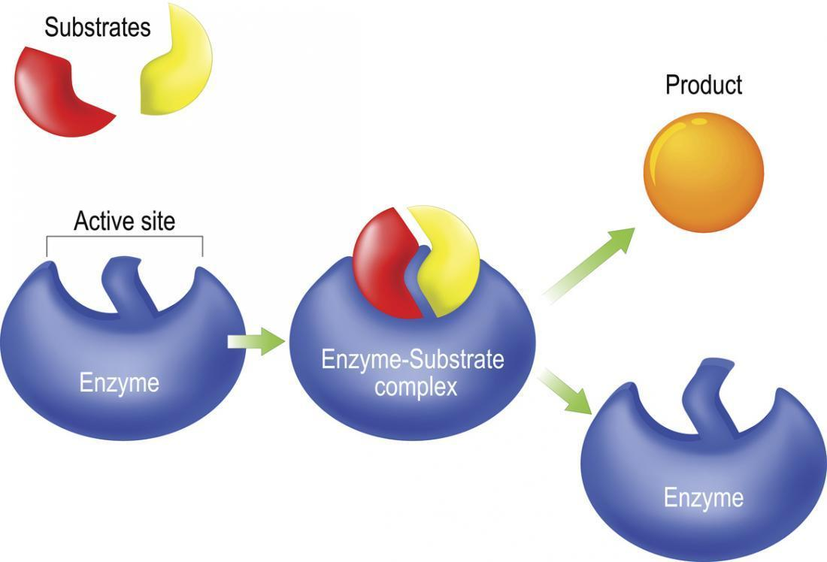

Substrate binding
Enzymes must bind their substrates before they can catalyse any chemical reaction. Enzymes are usually very specific as to what substrate they bind and then the chemical reaction catalysed. Specificity is achieved by binding pockets with complementary shape, charge and hydrophilic/hydrophobic characteristics to the substrates.

"Lock and key" model

The “lock and key” model was first proposed in 1894 by Emil Fischer. In this model, an enzyme’s active site is a specific shape, and only the substrate will fit into it, like a lock and key. This early model explains enzyme specificity, but fails to explain the stabilization of the transition state that enzymes achieve

Induced fit model
In 1958, Daniel Koshland suggested a modification to the lock and key model: since enzymes are rather flexible structures, the active site is continuously reshaped by interactions with the substrate as the substrate interacts with the enzyme. As a result, the substrate does not simply bind to a rigid active site; the amino acid side-chains that make up the active site are molded into the precise positions that enable the enzyme to perform its catalytic function. Once the substrate is fully locked in and in the exact position, the catalysis can begin.

CONDITIONS REQUIRED:
Enzymes can only work in certain conditions.
- Most enzymes in the human body work best at around 37°C – body temperature. At lower temperatures, they will still work but much more slowly.
- Similarly, enzymes can only function in a certain pH range (acidic/alkaline). Their preference depends on where they are found in the body. For instance, enzymes in the intestines work best at 7.5 pH, whereas enzymes in the stomach work best at pH 2 because the stomach is much more acidic.
If the temperature is too high or if the environment is too acidic or alkaline, the enzyme changes shape; this alters the shape of the active site so that substrates cannot bind to it – the enzyme has become denatured.

Cofactors
Some enzymes cannot function unless they have a specific non-protein molecule attached to them. These are called cofactors. Cofactors can be either inorganic (e.g., metal ions and iron-sulfur clusters) or organic compounds (e.g., flavin and heme). These cofactors serve many purposes; for instance, metal ions can help in stabilizing nucleophilic species within the active site.^{[54]} Organic cofactors can be either coenzymes, which are released from the enzyme's active site during the reaction, or prosthetic groups, which are tightly bound to an enzyme. Organic prosthetic groups can be covalently bound (e.g., biotin in enzymes such as pyruvate carboxylase).
An example of an enzyme that contains a cofactor is carbonic anhydrase, which uses a zinc cofactor bound as part of its active site.^{[56]} These tightly bound ions or molecules are usually found in the active site and are involved in catalysis.^{[1]:8.1.1} For example, flavin and heme cofactors are often involved in redox reactions.^{[1]:17}
Enzymes that require a cofactor but do not have one bound are called apoenzymes or apoproteins. An enzyme together with the cofactor(s) required for activity is called a holoenzyme (or haloenzyme).
Coenzymes are small organic molecules that can be loosely or tightly bound to an enzyme. Coenzymes transport chemical groups from one enzyme to another. Examples include NADH, NADPH and adenosine triphosphate (ATP). Some coenzymes, such as flavin mononucleotide (FMN), flavin adenine dinucleotide (FAD), thiamin pyrophosphate (TPP), and tetrahydrofolate (THF), are derived from vitamins. These coenzymes cannot be synthesized by the body de novo and closely related compounds (vitamins) must be acquired from the diet. Coenzymes and the protein portion with catalytic activity or apoenzyme form the holoenzyme. The apoenzyme is responsible for the enzyme’s substrate specificity. Coenzymes undergo changes to compensate for the transformations occurring in the substrate.
An enzyme that is inactive in the absence of its coenzyme is called an apoenzyme. In the presence of its coenzyme to produce the active form of the enzyme, it is called a holoenzyme:
apoenzyme+coenzyme⇌holoenzyme
Although some enzymes contain a coenzyme that is tightly bound, others may contain a coenzyme that is readily dissociable. In the latter case, the coenzyme can be considered as a reactant or substrate. Thus, in the lactate dehydrogenase reaction, for example, pyruvate and the coenzyme NADH need to be added to the enzyme and, kinetically, this would be considered to be a two-substrate reaction:
pyruvate+NADH⇌lactate+NAD+

Metalloenzymes are enzymes that contain metal ions. For instance, carbonic anhydrase, an enzyme that helps maintain the pH of the body, cannot function unless it is attached to a zinc ion.
Thermodynamics:
As is with all catalysts, enzymes do not alter the position of the chemical equilibrium of the reaction. In the presence of an enzyme, the reaction runs in the same direction as it would without the enzyme, just more quickly.^{[1]:8.2.3} For example, carbonic anhydrase catalyzes its reaction in either direction depending on the concentration of its reactants:^{[60]}
(in tissues; high CO₂ concentration) |  | (1)

(in lungs; low CO₂ concentration) |  | (2)
The rate of a reaction is dependent on the activation energy needed to form the transition state which then decays into products. Enzymes increase reaction rates by lowering the energy of the transition state. First, binding forms a low energy enzyme-substrate complex (ES). Secondly the enzyme stabilises the transition state such that it requires less energy to achieve compared to the uncatalyzed reaction (ES‡). Finally the enzyme-product complex (EP) dissociates to release the products.^{[1]:8.3}
Enzymes can couple two or more reactions, so that a thermodynamically favorable reaction can be used to "drive" a thermodynamically unfavourable one so that the combined energy of the products is lower than the substrates. For example, the hydrolysis of ATP is often used to drive other chemical reactions.
Inhibition
To ensure that the body’s systems work correctly, sometimes enzymes need to be slowed down. For instance, if an enzyme is making too much of a product, there needs to be a way to reduce or stop production.
Enzymes’ activity can be inhibited in a number of ways:
Competitive inhibitors – a molecule blocks the active site so that the substrate has to compete with the inhibitor to attach to the enzyme.
Non-competitive inhibitors – a molecule binds to an enzyme somewhere other than the active site and reduces how effectively it works.
Uncompetitive inhibitors – the inhibitor binds to the enzyme and substrate after they have bound to each other. The products leave the active site less easily, and the reaction is slowed down.
Irreversible inhibitors – an irreversible inhibitor binds to an enzyme and permanently inactivates it.

Examples of specific enzymes
There are thousands of enzymes in the human body, here are just a few examples:
- Lipases – a group of enzymes that help digest fats in the gut.
- Amylase – helps change starches into sugars. Amylase is found in saliva.
- Maltase – also found in saliva; breaks the sugar maltose into glucose. Maltose is found in foods such as potatoes, pasta, and beer.
- Trypsin – found in the small intestine, breaks proteins down into amino acids.
- Lactase – also found in the small intestine, breaks lactose, the sugar in milk, into glucose and galactose.
- Acetylcholinesterase – breaks down the neurotransmitter acetylcholine in nerves and muscles.
- Helicase – unravels DNA.
- DNA polymerase – synthesize DNA from deoxyribonucleotides.

In a nutshell
Enzymes play a huge part in the day-to-day running of the human body. By binding to and altering compounds, they are vital for the proper functioning of the digestive system, the nervous system, muscles, and much, much more.

